Name Yash Pratap Singh Batch- August (2024)

Data Structure Algorithm Assignment -2

Question 1:- <https://leetcode.com/problems/two-sum/description/> (leetcode 1).

Solution 1:- https://leetcode.com/problems/two-sum/submissions/1473514412/

Time complexity: O(n).

Space complexity: O(n).

Description: Time complexity we have used loop which iterate over the array once and every hash map lookup take constant time so the over all loop will take o(n) time so the time complexity O(n). Space complexity we have used hash map to store n elements of where n is the size of n elements in the array so it also becomes O(n).

Added screenshot.

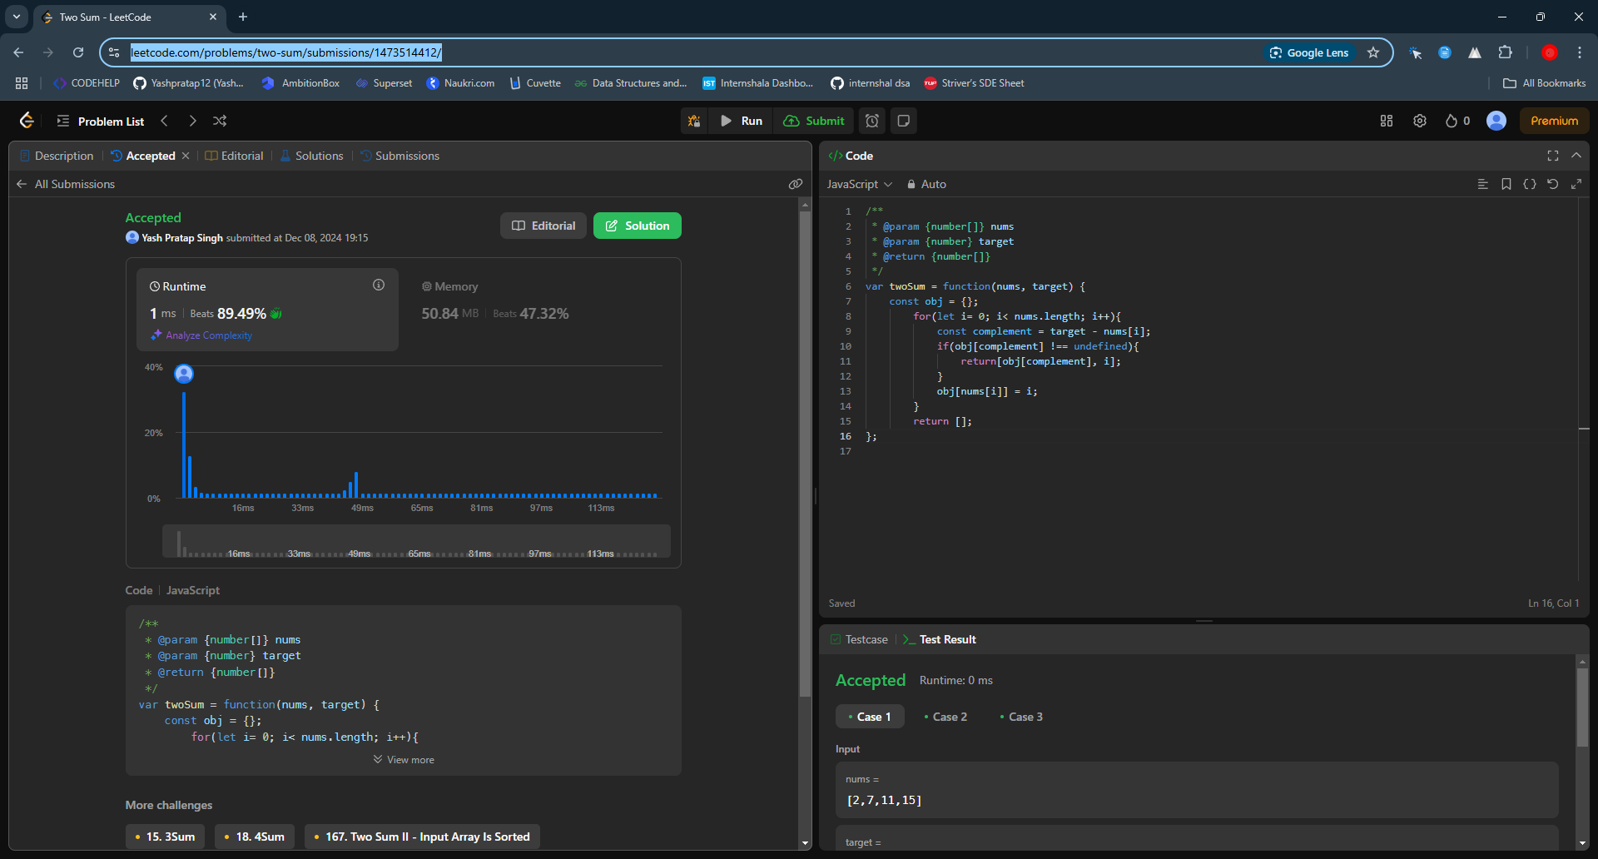.

Question 2:- <https://leetcode.com/problems/3sum/description/>(leetcode 15).

Solution 2:- https://leetcode.com/problems/3sum/submissions/1473532963/

Time complexity: O(n^2).

Space complexity: O(n).

Description: Time complexity : sorting take O(n log n) and two pointer approach involves a loop O(n) through the array and another nested loop with two pointers which make up O(n^2).

Space complexity: we have used extra array to store result which holds up O(n) triplet so the space complexity becomes O(n).

Added screenshot.

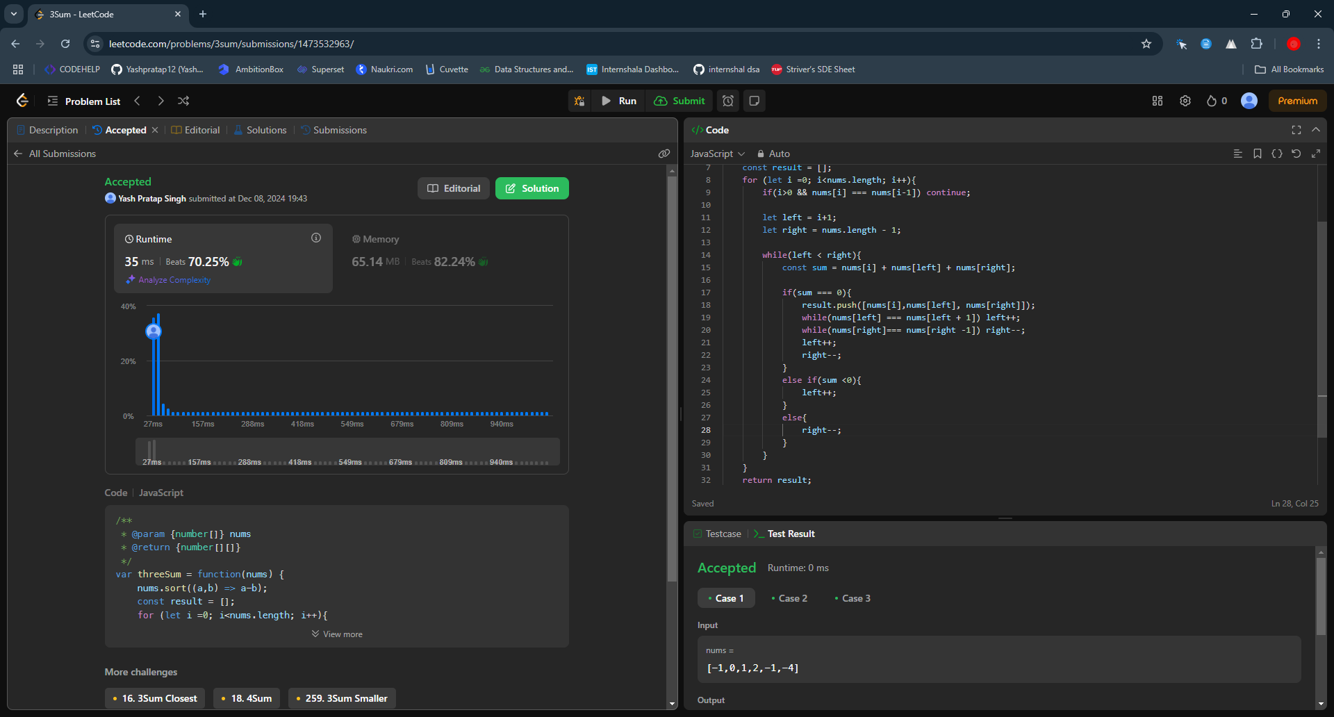.

Question 3:- <https://leetcode.com/problems/long-pressed-name/description/>(leetcode 925).

solution 3:- https://leetcode.com/problems/long-pressed-name/submissions/1473575911/

Time complexity: O(n).

Space complexity: O(1).

Description: Time complexity- In the code for traversing through the typed string once, with each comparison being O(1) and let length of the typed string is n then it becomes O(n).

Space complexity- O(1) we are using two pointers which is i and j and no extra data structure are required.

Added Screenshot.

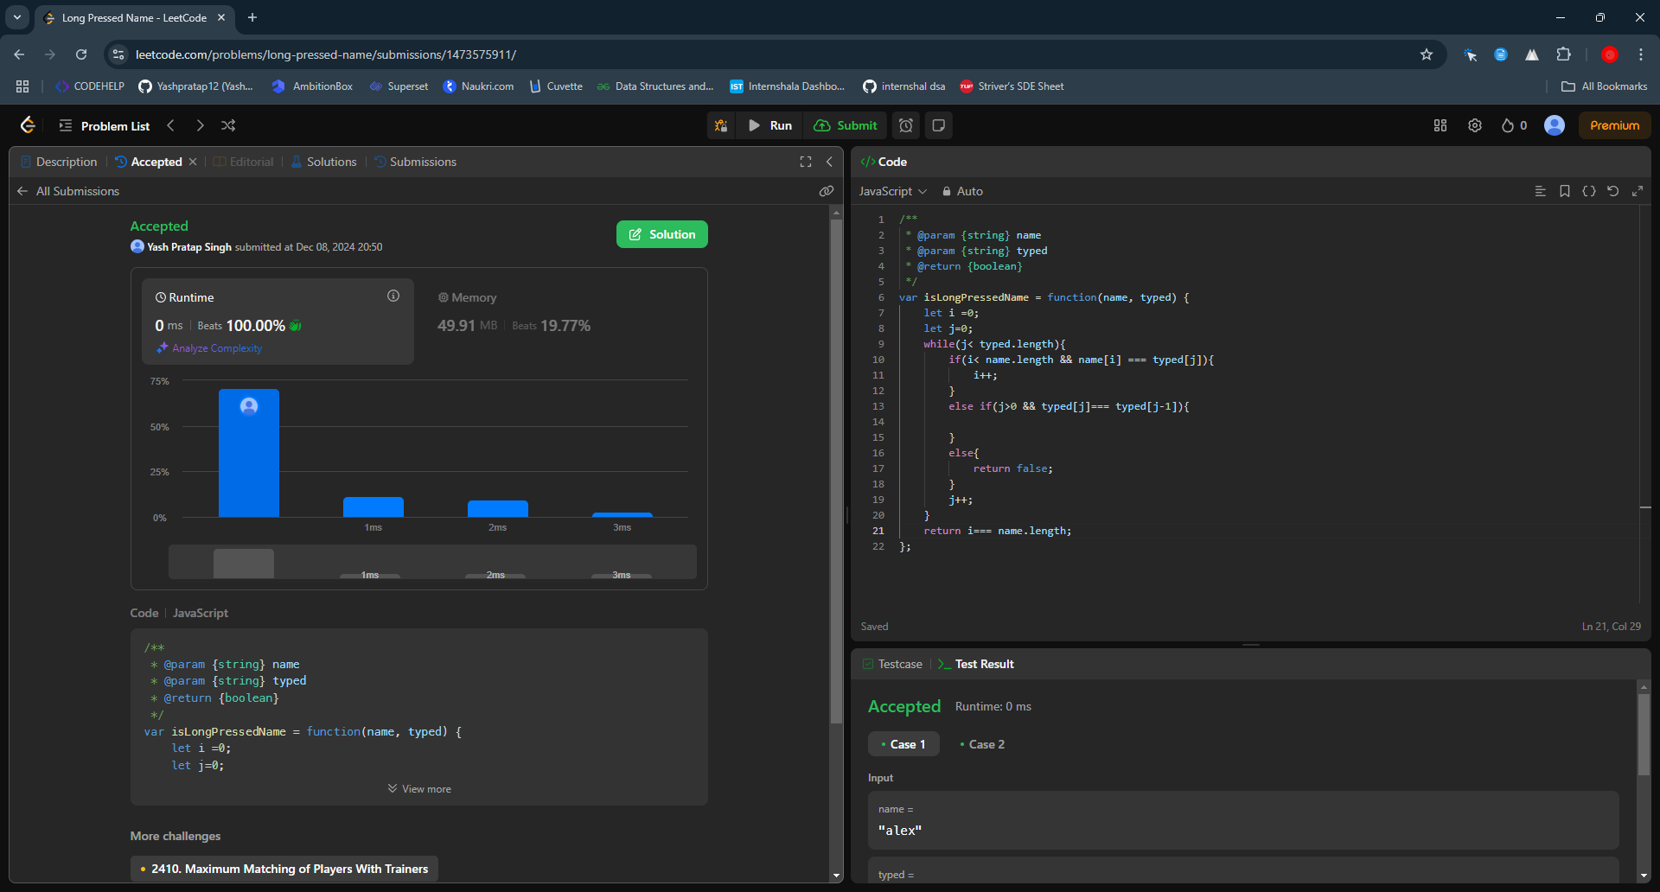

Question 4- <https://leetcode.com/problems/max-chunks-to-make-sorted/description/>(leetcode 769)

solution 4 - https://leetcode.com/problems/max-chunks-to-make-sorted/submissions/1473587507/

Time complexity: O(n).

Space complexity: O(1).

Description: Time complexity : As we have used a for loop to iterate through the array and if the length of the array is then it will become n times so the complexity becomes O(n).

Space complexity- we haven’t used any extra space which scales with the input size so the complexity is o(1).

Added Screenshot.

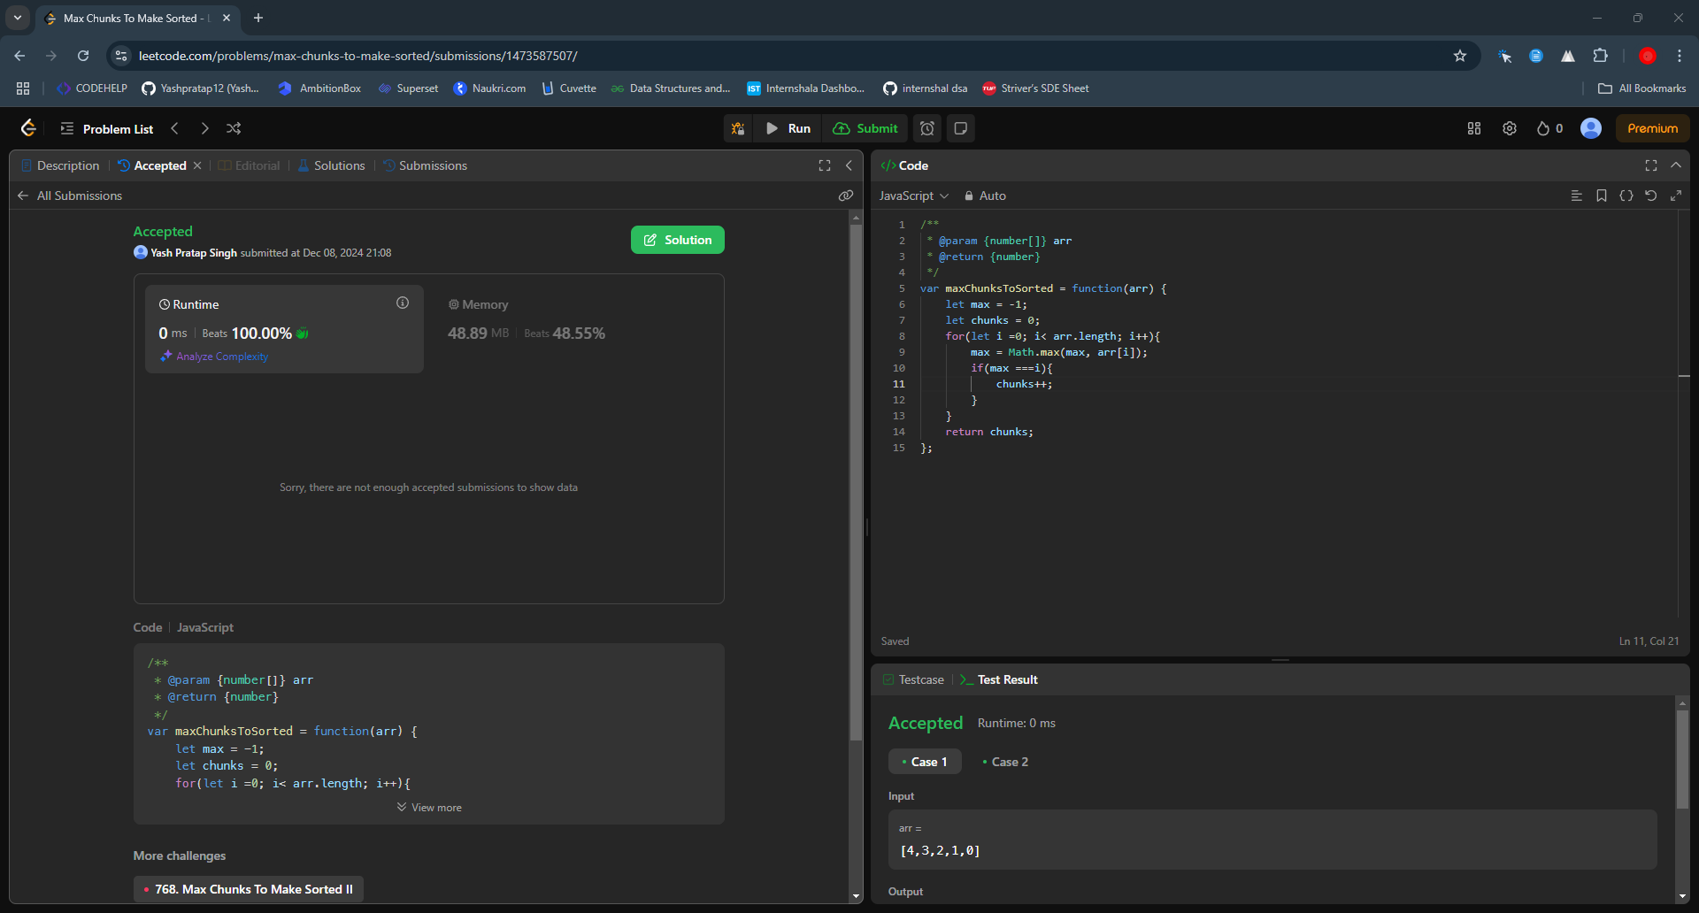

Question 5- <https://leetcode.com/problems/sort-colors/description/>(leetcode 75)

solution 5:- https://leetcode.com/problems/sort-colors/submissions/1473600113/

Time complexity: O(n).

Space complexity: O(1).

Description: Time complexity : Every element in the array is processed at most once and the while loop runs until the mid crosses high which make time complexity O(n0.

Space complexity as we haven’t used any extra space to excute the program so it is O(1).

Added Screenshot.

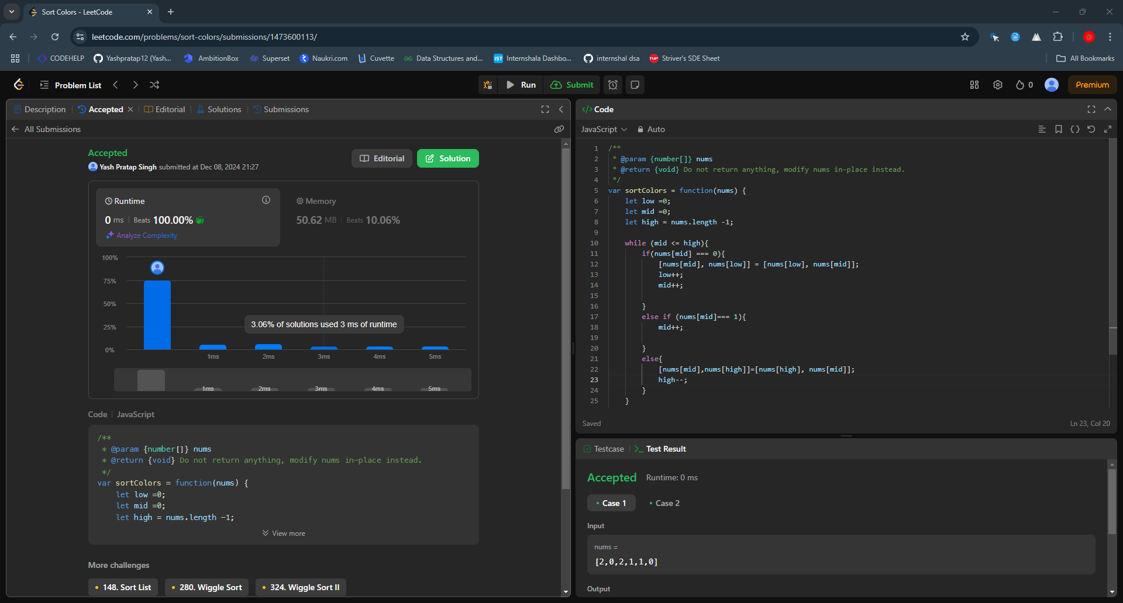.

Question 6- <https://leetcode.com/problems/maximum-subarray/description/> (leetcode 53).

solution 6- <https://leetcode.com/problems/maximum-subarray/submissions/1473609973/>

Time complexity: O(n).

Space complexity: O(1).

Description: Time complexity in this problem we have used one for loop to traverse the array once performing constant time operation for each element so the time complexity becomes o(n).

Space complexity as we have used only few variable which do not depends on size of the array so it will not take extra space which makes time complexity O(1).

Added Screenshot.

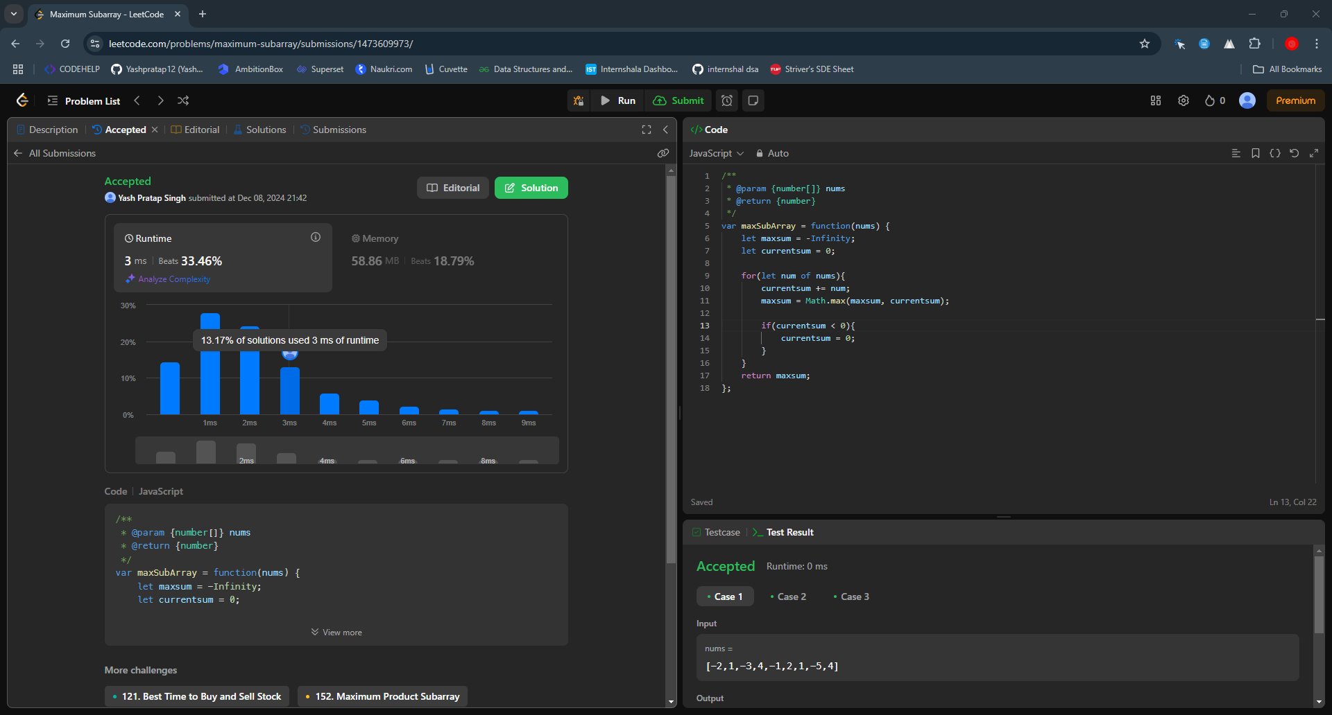.

Question 7- <https://leetcode.com/problems/move-zeroes/description/> (leetcode 283)

solution 7- <https://leetcode.com/problems/move-zeroes/submissions/1473619069/>

Time complexity: O(n).

Space complexity: O(1).

Description:

Time complexity: in this solution we have used two loops first loop iterates through the array to move non zero elements and the second loop to iterate from nonzeroindex to the end to fill zeros so when you see at broader picture its only single traversal which is making time complexity O(n).

Space complexity: here no extra data structure or space is used so the space complexity remains O(1) for the program.

Added Screenshot.

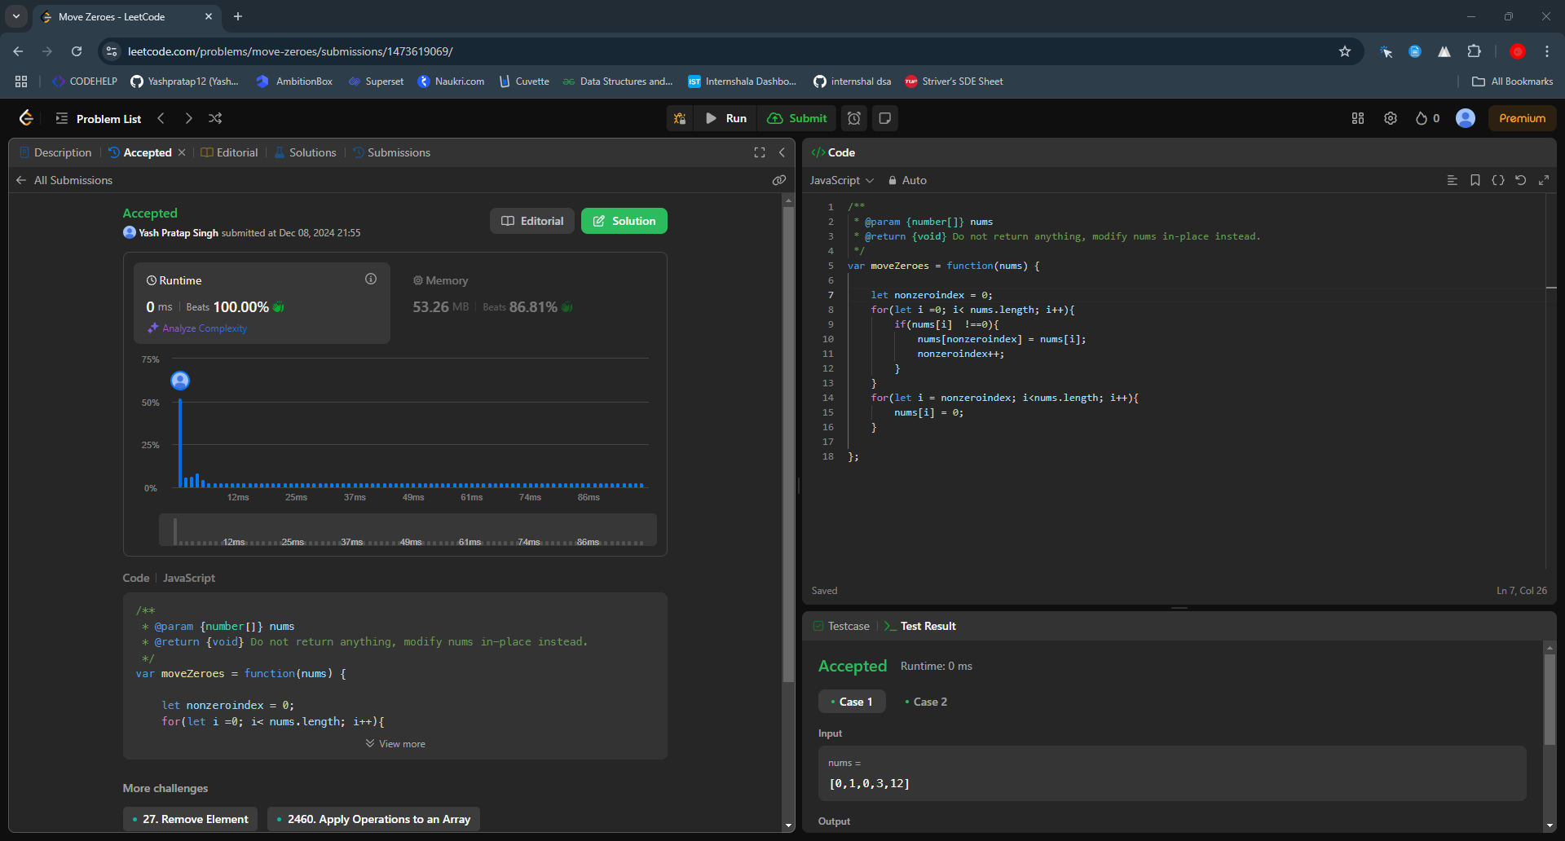.

Leetcode Id - <https://leetcode.com/u/yashprataps992/> (Yash Pratap Singh)